What drives ant species distributions and coexistence?

Does ant community assembly shift with stress?

What are the roles of foundation plants in modulating ant community assembly.

Consider this question on three scales:

Regional: California or SJV

Sites: 9 sites sampled 3 times = 27

Microsites – pitfall traps 24 per site, 12 shrub/12 open or 24 open

Species distribution models

1. Range of environmental niche
2. A measure of suitability at the site level

Predictions

|  |  |  |
| --- | --- | --- |
| Calculation, Response | Prediction | Variables/Data/Predictor |
| Species distribution overlap | Species with a greater ~~spatial~~ overlap have more similarities in their abiotic requirements/adaptations. Compare large scale similarity to small scale similarity | Aridity, temps, elevation, shrub cover |
| Fine scale spatial partitioning | Trait partitioning between microsites within sites |  |
| Niche differentiation | Traits should become more different in response to the local environment  Species more similar in niche should co-occur less frequently at finer spatial scales | Tom white reglation vs limitation, CSR vs continuum  If ant species   1. Co-occurrence stress gradient, direct or indirect.. relative coocure 2. Distentangling approach   Ficheaux  Sem structural partitioning  Variance partition exercise  What is structuring the difference?  Table 1 –  Femur length  Mandible length  Do species that spend more time under shrubs have different traits? Related to foraging  Shrubs have longer mandible  Plant baggage – negative aspects of interactions |
| Habitat filtering | Traits should become more similar in response to the environment  Species more similar in niche should co-occur more frequently at the regional scale |  |
| Habitat filtering | Filtering should become more important with increasing stress |  |
| Body size when co-occuring at pitfall and site levels vs not | Body size should change when co-occuring if character displacement mediates coexistence  Body size overlap should decrease with co-occurrence |  |
| Is relative abundance driven more strongly by abiotic or biotic factors? |  | Maybe use SEM to parse abiotic and biotic components |
| Phylogeny | Phylogenetic dissimilarity predicts co-occurence (unrelated species more likely to co-occur?) | Predicted co-ocurrence when more dissimilar  Do shrubs homogenize the enivorment? |
| Ecosystem engineers: Do coexistence patterns differ between shrub and open, and shrubbed and unshrubbed sites. | Co-occurrence becomes more aggregated or segregated |  |
| Stress gradient | Environmental stress will predict the SES for traits, hmm. SES is the deviance of observed to null models of particular assembly processess |  |
|  | Is a species more likely to exist alone when in its prefered habitat? |  |

1. How long of gradient for stress gradient
2. Is habitat heterogeneity the same as the environment or is it variation in the environment.
3. Traits vs. habitat -> Some papers use some habitat to try and control for responses, then use traits, others use habitat
4. Is a species competitive ability dependent on the environment or would that be a competition/stress tradeoff?

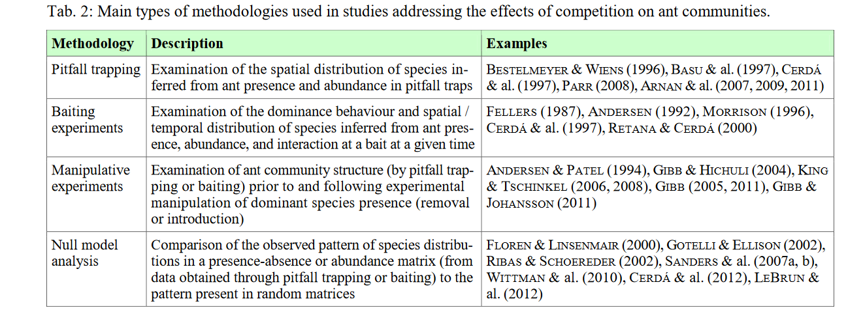

Potential approaches:

Model ecological niche using traits:

Fundamental grinellian niche : Lit search for physiological tolerances (heat and aridity)

More questions: Do shrub associated insects have a lower climatic tolerance?

What does insect-insect facilitation look like?

Steps:

Extract aridity and temperature niches from SDMs.

and the local relative abundance of species expected when considering only abiotic conditions.

Then, we estimated the main features of species niche (niche optimum, niche breadth and niche skewness), calculated a community-weighted mean of such features, and evaluated their variation along aridity gradients to identify changes in common strategies of species specialization to aridity across environmental gradients. Third, we evaluated the effect of both aridity and plant-plant interactions (as extracted from co-occurrence analyses) on the relative abundance of species within each community. Finally, we evaluated changes in the relative importance of abiotic/biotic assembly drivers along gradients of aridity and of niche specialisation of the species in our communities. These steps are described in detail below.

We used linear mixed models to analyse the relative abundances of each species as a function of: i) aridity-driven abundance, ii) cumulative effects of both competition-driven and facilitation-driven abundances, and iii) the height of the target species ([equation 5](https://www.biorxiv.org/content/10.1101/147181v1.full#disp-formula-5), [Fig. 1.c](https://www.biorxiv.org/content/10.1101/147181v1.full#F1)). Plant height was introduced to control for potential confounding effects between cover (used to estimate relative abundance in the field) and the size of the species being sampled (taller species are more likely to score higher cover values regardless of their abundance).

As species relative adaptation to local aridity may influence the importance of facilitation and competition ([Choler et al. 2001](https://www.biorxiv.org/content/10.1101/147181v1.full#ref-12); [Liancourt et al. 2005](https://www.biorxiv.org/content/10.1101/147181v1.full#ref-26); [Gross et al. 2010](https://www.biorxiv.org/content/10.1101/147181v1.full#ref-18); [Soliveres et al. 2014](https://www.biorxiv.org/content/10.1101/147181v1.full#ref-43)), we established an interaction between aridity-driven (derived from the niches and summarizing species suitability to local conditions) and competition- and facilitation-driven abundances. Interactions between aridity and competition and facilitation will be positive if the effect of plant-plant interactions on relative abundance is higher for locally adapted species than for species not adapted to local conditions. It must be noted that the effects of competition are negative, therefore positive contributions from the interaction term decrease the effect of competition on the relative abundance of species adapted to local aridity conditions. Thus, our final model was:

To quantify the effects of environmental heterogeneity and niche overlap on species co-occurrence patterns at different levels of niche breadth, I used two approaches. For the modelled communities, I developed multivariate linear models with SES as the dependent variable and niche overlap and environmental heterogeneity as the independent variables. For the empirical communities, I developed linear mixed models with the same variable designations as above, but added cluster identity as a random effect. In both model types, I compared the effects of the two heterogeneity metrics (range and coefficient of variation of environmental conditions). To account for the effect of niche breadth, I grouped species according to different levels of niche breadths and developed the models separately for each group. To group species according to niche breadth, I divided them according to their *σ* value in the analysis of modelled communities; in the analysis of the empirical communities, I grouped them into bins according to their percentile in the distribution of niche breadth values (0–20%, 21–40%, 41–60%, 61–80% and 81–100%). I did not analyse the effects of niche breadth for species pairs in which each species belonged to a different niche breadth percentile.

Mechanisms of coexistence come from tradeoffs among organisms and environmental variation.

Habitat filtering at the community level leads to a trait convergence at a trait optima in response to the local environment.

Niche differentiation leads to trait divergence and promotes species coexistence. They are not exclusive.

Simple models based on niche predict that when 2 species share a resource the one that needs less to maintain their population will survive.

When species are both impacted by stress but cannot alter it, is more complicated. If the intensity of stress is greater than one species tolerance but not the others, the species with the greater tolerance will win. When it is greater than both, neither can exist. If it is less than eithers, than need more information to predict.

Zero net growth isocline – boundary of species niche.

Liebig’s law of the minimum – the growth rate of a species is determined by the resource is finds most limiting.

Species can coexist sharing resources and stress if one species is a better competitor under stress but worse at dealing with it.

Coexistence of species with similar tradeoffs requires 2 linked tradeoffs.

1. Each species must differ in the factor it finds most limiting
2. Each species must have a greater impact on the factor it finds most limiting.

Interspecific competition must be less than intraspecific competition for two species to stable coexist.

One of hutchison’s biggest contributions was the distinction between the fundamental and the realized niche – the fundament being the niche when not constrained by biotic interactions. The insight is that species can exist in a greater range of environmental conditions when their competitors are absent.

The realized niche is conditional. Stress doesn’t enhance local diversity because species do not impact it. But ecosystem engineers do. Habitat is a subset of the niche.

Niche results for the interactions between species and the environment, so there are no empty niches.

The author’s think there are 2 empirical useful methods 1) Reaction norms: Estimate fitness components in response to a factor of interest 2) Behavioural decisioins as an indicator of costs and benefits in relation to a factor of interest

GUD the giving up density is likely correlated with the density where a species net fitness is zero. Therefore, the GUD for a species is an index of its relative competitive ability for a given resource and therefore its R*.

